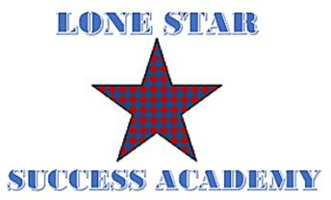
Lone Star Success Academy Meeting Agenda/Notice
Thursday
August 20, 2020
10:30am (CST)
********************************************
To join the meeting
************************************************
Telephone:
Dial: US: 1-699-900-6833
Meeting ID: 432-952-9991#
Notice is hereby given that on the 15th day of July 2020, the School Board of Lake Granbury Academy Charter School will hold a regular board meeting at 10:30 a.m. at the Lake Granbury Youth Service Program Administration Office, 1300 Crossland Rd, Granbury, TX. The subjects to be discussed, considered, or upon which any formal action may be taken are as listed below. Please note that the sequence of items given in the posting is only approximate and that the order of individual items may be adjusted as necessary.
- Call to Order and Establish Quorum
- Welcome and Recognition of Special Guests:
- Action Items
  - Consider Board approval of Board Minutes for the Meeting held on July 16, 2020
  - Consider Board approval of SY21 Budget
- Reports/Discussion Items
Superintendent and School Report:
- COVID-19 Update (request changes to current guidelines)
- Change the 5-day campus closure requirement after one positive case to allow schools to follow local health authority DSHS, or CDC guidelines. Public health experts and CDC guidelines on sanitation say that only 24-48 hours is needed following the deep clean, and even then, much depends on who was exposed to the person who tested positive, was the person who tested positive wearing PPE, what spaces they were they in, etc.
- In light of the looming teacher/other personnel shortage, waive as many requirements as possible around certified teachers and other staff (not the requirements around background checks, fingerprint database checks, etc.).
- If a Local Public Health Authority orders schools closed, allow schools to transition into 100% virtual with full funding without prior approval of TEA.
- Remove the instructional minutes requirement and additional days requirement for HB 3 supplemental funding for this year.
- School Staffing Update – CTE, Science, and School Leader
  - ESOL endorsement is a compliance area
  - Few applicants applying
  - Budget review for hiring incentive
- School Culture:
  - Possible 5 December graduates
  - RITENow on PBIS Model
  - Project-based learning sessions for students
  - Struggles with mask wearing
- Website compliance – self-directed work team
- NSLP Audit – September 13th
- Finance Report
- Adjournment:

Tracy Bennett-Joseph, M.Ed.
Lake Granbury Academy Charter School Superintendent

